COMPANY PROFILE
OFFICIAL NAME
FM Sardan Customs Brokerage and Consultancy (FMSCBC)
VISION
FM Sardan Customs Brokerage and Consultancy envisions to be a globally engaged trade partner creating sustainable impact in society and the economy.
MISSION
FM Sardan Customs Brokerage and Consultancy seeks to provide strategic customs brokerage, trade facilitation, and consultancy services through the highest standards of compliance, integrity, professionalism, and innovation, committed to advancing responsible trade and sustainable economic development.
PHILOSOPHY OF BUSINESS
Creating Sustainable Impact Through Responsible Trade
FM Sardan Customs Brokerage and Consultancy believes that responsible trade serves as a catalyst for economic growth, industry advancement, and societal progress. By facilitating lawful, efficient, and ethical trade practices, the firm creates lasting value for businesses while contributing to sustainable development and nation-building.
CORE VALUES
The S.A.R.D.A.N. Values Framework
S – Strategic Excellence
We pursue excellence with purpose, foresight, and impact. Through expertise, innovation, and value-driven solutions, we strive to create meaningful outcomes that support business success, strengthen trade competitiveness, and contribute to sustainable economic growth.
A – Accountable Leadership
We lead through responsibility, ownership, and trust. We take accountability for our actions, decisions, and commitments while fostering transparency, reliability, and confidence among our clients, partners, and stakeholders.

R – Resolute Integrity
We remain unwavering in our commitment to honesty, ethics, fairness, and doing what is right. We uphold the highest standards of moral and professional conduct, recognizing that trust is the foundation of every lasting relationship and every successful enterprise.
D – Distinguished Professionalism
We uphold exceptional standards of competence, conduct, and service excellence. Through continuous learning, expertise, respect, and dedication to quality, we strive to distinguish ourselves as trusted professionals in customs brokerage and trade consultancy.
A – Adaptive Innovation
We embrace change, continuous improvement, and innovative thinking. By leveraging knowledge, technology, and creative solutions, we remain responsive to the evolving demands of global trade and the needs of our clients.
N – Nation Building
We contribute to the advancement of society and the economy through responsible trade, lawful business practices, and professional excellence. We believe that facilitating trade is not only a business endeavor but also a meaningful contribution to national development and shared prosperity.
CORPORATE TAGLINE
“Connecting Borders, Expanding Possibilities”

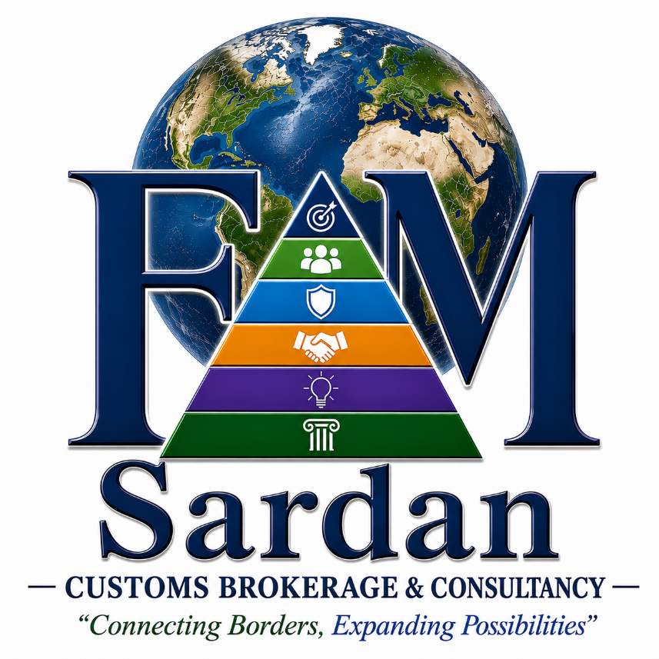
LOGO:

Official Logo Symbolism and Meaning:
The FMSCBC logo is more than a visual identity—it is a representation of the firm's vision, mission, philosophy, values, and commitment to global trade, professional excellence, and nation-building. Every element of the logo has a deliberate meaning that collectively communicates the firm's purpose and aspirations.
1. THE GLOBE
Symbol of Global Trade and International Connectivity
The globe represents the worldwide nature of commerce and the firm's role in facilitating international trade. As customs brokerage and trade consultancy services connect businesses across countries, the globe symbolizes:
- Global Engagement
- International Trade
- Cross-Border Commerce
- Worldwide Connectivity
- Economic Integration
- Global Opportunities
The realistic world map reinforces the firm's commitment to operating within the international trade environment and reflects its vision of becoming a globally engaged trade partner.
Relation to the Vision
"FM Sardan Customs Brokerage and Consultancy envisions to be a globally engaged trade partner creating sustainable impact in society and the economy."
The globe serves as the visual embodiment of this vision.
2. THE LETTERS "F" AND "M"
Symbol of Identity, Leadership, and Legacy
The large letters F and M represent the owners first name:
F – Ferddy
M – Mark also represents, Management, Mastery, Mission, and Momentum
The letters stand prominently on both sides of the pyramid, representing stability and strength.
The partial overlap of the pyramid over the letters signifies that:
- Values and principles stand at the center of leadership and business operations.
- The firm's identity is therefore not built merely on a name but upon the values represented by the pyramid.
3. THE PYRAMID
Symbol of Growth, Stability, and Excellence
The pyramid represents:
- Structured Growth
- Organizational Stability
- Continuous Improvement
- Strategic Development
- Long-Term Sustainability
A pyramid is one of history's strongest and most enduring structures. Likewise, FMSCBC seeks to build a firm that is sustainable, resilient, and capable of creating lasting impact.
The upward direction of the pyramid symbolizes:
- Progress
- Achievement
- Excellence
- Advancement
- Future Growth
4. THE SIX PYRAMID LEVELS
The S.A.R.D.A.N. Values Framework
The pyramid contains six levels representing the six core values of the firm.
Level 1 – Strategic Excellence
Icon: Target
Color: Deep Navy Blue
Meaning
The target symbolizes:
- Vision
- Strategic Direction
- Precision
- Goal Achievement
Strategic Excellence reflects the firm's commitment to delivering high-quality customs brokerage and consultancy services through foresight, planning, and purposeful execution.
Level 2 – Accountable Leadership
Icon: People / Team
Color: Green
Meaning
The people icon symbolizes:
- Leadership
- Teamwork
- Responsibility
- Trust
Accountable Leadership emphasizes ownership of actions, transparency, and responsible decision-making.
The green color represents:
- Growth
- Sustainability
- Development
- Partnership
Level 3 – Resolute Integrity
Icon: Shield
Color: Light Blue
Meaning
The shield represents:
- Integrity
- Protection
- Trustworthiness
- Compliance
Resolute Integrity reflects unwavering commitment to ethical conduct and lawful trade practices.
The blue tone symbolizes:
- Security
- Reliability
- Compliance
- Confidence
Level 4 – Distinguished Professionalism
Icon: Handshake
Color: Gold / Orange
Meaning
The handshake symbolizes:
- Professional Relationships
- Mutual Respect
- Client Trust
- Service Excellence
Distinguished Professionalism signifies competence, credibility, and a commitment to exceptional service.
The gold color represents:
- Excellence
- Achievement
- Value Creation
- Professional Success
Level 5 – Adaptive Innovation
Icon: Light Bulb
Color: Purple
Meaning
The light bulb symbolizes:
- Innovation
- Creativity
- Continuous Improvement
- Modern Solutions
Adaptive Innovation reflects the firm's willingness to evolve, adopt technology, and continuously improve services.
The purple color symbolizes:
- Innovation
- Vision
- Transformation
- Forward Thinking
Level 6 – Nation Building
Icon: Pillar
Color: Emerald Green
Meaning
The pillar symbolizes:
- Strength
- Foundation
- Nation Building
- Institutional Stability
Nation Building reflects the firm's commitment to contributing to economic growth and national development through responsible trade.
The emerald green color represents:
- Prosperity
- Economic Growth
- Sustainability
- National Progress
5. THE NAME "Sardan"
The name Sardan serves as the firm's primary identity and brand and also the last name of the founder.
Its placement beneath the pyramid signifies that:
The firm's reputation is built upon the foundation of its values.
The bold and prominent typography reflects:
- Authority
- Stability
- Professional Credibility
- Corporate Strength
6. CUSTOMS BROKERAGE & CONSULTANCY
The descriptor clearly communicates the firm's dual role:
Customs Brokerage
- Customs Clearance
- Regulatory Compliance
- Import and Export Processing
- Trade Documentation
Consultancy
- Trade Advisory
- Customs Management
- Strategic Trade Solutions
- Regulatory Guidance
This positioning establishes FMSCBC not merely as a customs processor but as a strategic trade partner.
7. THE TAGLINE
“Connecting Borders, Expanding Possibilities”
This tagline captures the essence of the firm's work.
Connecting Borders
Represents:
- International Trade
- Cross-Border Commerce
- Global Connectivity
- Trade Facilitation
The phrase reflects the firm's role in helping businesses move goods, services, and opportunities across international boundaries.
Expanding Possibilities
Represents:
- Business Growth
- New Markets
- New Opportunities
- Economic Advancement
- Trade Expansion
It emphasizes that trade is not merely about moving cargo; it is about creating opportunities for businesses, industries, communities, and economies.
Why It Fits the Logo
The globe symbolizes Connecting Borders.
The upward pyramid symbolizes Expanding Possibilities.
Together, they visually express the tagline.
COMPLETE LOGO MESSAGE
When viewed as a whole, the logo communicates:
FM Sardan Customs Brokerage and Consultancy is a globally engaged trade partner founded on strong values, committed to responsible trade, professional excellence, innovation, integrity, and nation-building, while connecting borders and expanding possibilities for businesses, society, and the economy.

FOR THE WEBSITE
OUR SERVICES
1. Customs Brokerage Services
Facilitating the efficient and compliant clearance of imported and exported goods through the Bureau of Customs.
Services Include:
- Import Customs Clearance
- Export Customs Clearance
- Informal and Formal Entry Processing
- Customs Documentation Processing
- Duty and Tax Computation
- Cargo Release Coordination
- Customs Representation
2. Trade Compliance Services
Helping businesses comply with customs laws, trade regulations, and government requirements.
Services Include:
- Customs Compliance Review
- Regulatory Compliance Advisory
- Trade Compliance Assessment
- Customs Audit Preparation
- Post-Clearance Compliance Support
- Risk Assessment and Mitigation
3. Tariff Classification and Customs Valuation Services
Ensuring proper classification and valuation of goods to minimize risks and ensure compliance.
Services Include:
- HS Code Determination
- Tariff Classification Review
- Customs Valuation Consultation
- Dutiable Value Analysis
- Tariff Rate Verification
- Advance Classification Support
4. Documentary Compliance and Trade Documentation
Preparing and reviewing trade-related documents to ensure accuracy and regulatory compliance.
Services Include:
- Import and Export Documentation
- Permit and License Coordination
- Trade Document Verification
- Customs Documentation Review
- Certificate of Origin Assistance
- Documentary Compliance Audit
5. Accreditation and Registration Services
Assisting businesses in securing the necessary government registrations and accreditations.
Services Include:
- BOC Accreditation
- Importer Registration
- Exporter Registration
- CPRS Registration and Updating
- PEZA and Freeport Documentation Assistance
- Government Agency Registration Support
6. Trucking and Logistics Coordination
Providing cargo movement and logistics support from ports to final destinations.
Services Include:
- Port-to-Warehouse Delivery
- Container Hauling
- Cargo Transportation Coordination
- Inland Logistics Support
- Shipment Monitoring and Coordination
- Delivery Scheduling
7. Trade Consultancy and Business Advisory
Providing strategic guidance for businesses engaged in international trade.
Services Include:
- Import and Export Advisory
- Trade Strategy Development
- Market Expansion Consultation
- Trade Risk Assessment
- Customs and Trade Planning
- Supply Chain Advisory
8. Supply Chain and Trade Facilitation Solutions
Supporting businesses in improving efficiency across their international trade operations.
Services Include:
- Trade Process Optimization
- Supply Chain Assessment
- Logistics Coordination
- Trade Facilitation Advisory
- Customs Process Improvement
- Cross-Border Trade Solutions
9. Training and Capacity Development Programs
Enhancing the knowledge and competencies of organizations and trade practitioners.
Services Include:
- Customs and Tariff Seminars
- Import and Export Training
- Trade Compliance Workshops
- Corporate Training Programs
- Logistics and Supply Chain Training
- Academic and Professional Development Programs

INITIAL WEBSITE DESIGN
